**FACEBOOK DATASET**

* **Sharon Blessy J V**

1. **How does the time of upload [‘status published’] affect the 'num reaction’?**

**Ans.**

***Code Snippet:***

**from datetime import time**

**fd['status_published'] = pd.to_datetime(fd['status_published'])**

**fd['date'] = fd['status_published'].dt.date**

**fd['time'] = fd['status_published'].dt.time**

**def categorize_time(t):**

**if time(0, 0) <= t < time(12, 0):**

**return 'Morning'**

**elif time(12, 0) <= t < time(15, 0):**

**return 'Afternoon'**

**elif time(15, 0) <= t <= time(23, 59):**

**return 'Evening'**

**else:**

**return 'Unknown'**

**fd['Time_Category'] = fd['time'].apply(categorize_time)**

**relation = fd.groupby(['Time_Category','date'])['num_reactions'].sum().unstack()**

**relation_reset = relation.reset_index()**

**relation_melted = relation_reset.melt(id_vars='Time_Category', var_name='date', value_name='num_reactions')**

**sns.barplot(x='Time_Category', y='num_reactions', data=relation_melted, palette="viridis")**

**plt.xlabel('Time of Upload')**

**plt.ylabel('Number of Reactions')**

**plt.title('Number of Reactions Over Time')**

**plt.xticks(rotation=45)**

**plt.show()**

***Output:***

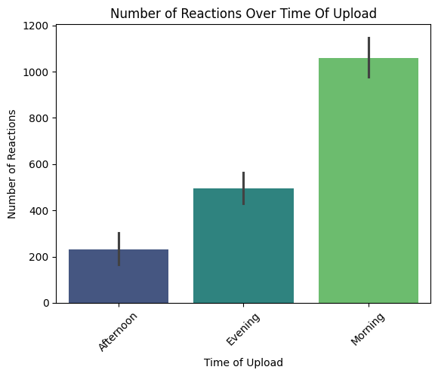

Posts uploaded in the morning have a greater no, of reactions when compared to posts uploaded in the afternoon and evening.

1. **Is there a correlation between the number of reactions (num_reactions) and other engagement metrics such as comments (num_comments) and shares (num_shares)? If so, what is the strength and direction of this correlation?**

**Ans.**

***Code Snippet:***

**correlation_matrix = fd[['num_reactions', 'num_comments', 'num_shares']].corr()**

**print(correlation_matrix)**

***Output:*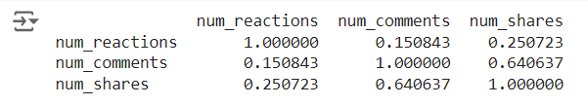**

1. **Use the columns status_type, num_reactions, num_comments, num_shares, num_likes, num_loves, num_wows, num_hahas, num_sads, and num_angrys to train a K-Means clustering model on the Facebook Live Sellers dataset.**

**Ans.**

***Code Snippet:***

**columns = ['status_type', 'num_reactions', 'num_comments', 'num_shares',**

**'num_likes', 'num_loves', 'num_wows', 'num_hahas', 'num_sads', 'num_angrys']**

**data = fd[columns]**

**data = pd.get_dummies(data, columns=['status_type'], drop_first=True)**

**scaler = StandardScaler()**

**data_scaled = scaler.fit_transform(data)**

**wcss = []**

**for i in range(1, 11):**

**kmeans = KMeans(n_clusters=i, init='k-means++', random_state=42)**

**kmeans.fit(data_scaled)**

**wcss.append(kmeans.inertia_)**

**plt.plot(range(1, 11), wcss, marker = 'o')**

**plt.title('Elbow Method')**

**plt.xlabel('Number of clusters')**

**plt.ylabel('WCSS')**

**plt.show()**

**# Train the K-Means model with 3 clusters**

**kmeans = KMeans(n_clusters=3, init='k-means++', random_state=42)**

**clusters = kmeans.fit_predict(data_scaled)**

**# Add cluster labels to the original dataset**

**data['Cluster'] = clusters**

**print(data.head())**

***Output:*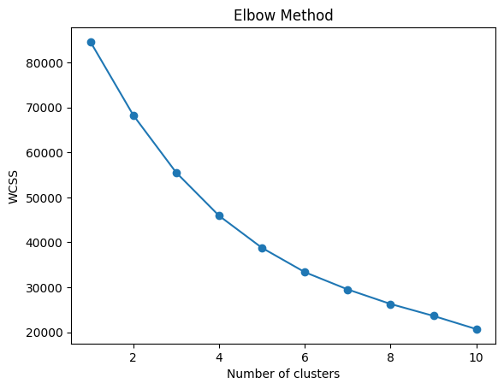**

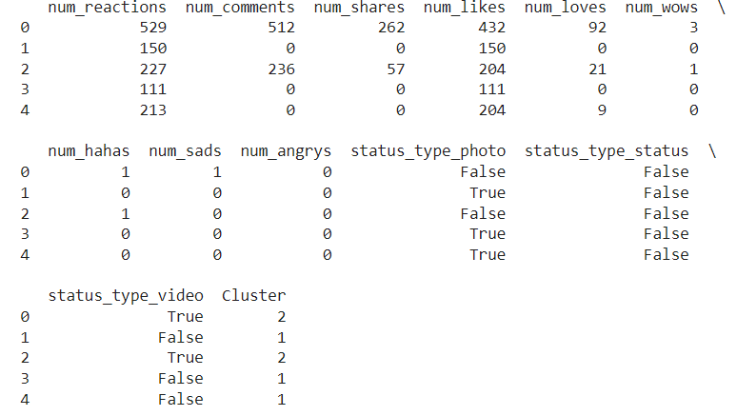

1. **Use the elbow method to find the optimum number of clusters.**

**Ans.**

***Code Snippet:***

**columns = ['status_type', 'num_reactions', 'num_comments', 'num_shares',**

**'num_likes', 'num_loves', 'num_wows', 'num_hahas', 'num_sads', 'num_angrys']**

**data = fd[columns]**

**data = pd.get_dummies(data, columns=['status_type'], drop_first=True)**

**scaler = StandardScaler()**

**data_scaled = scaler.fit_transform(data)**

**# Elbow method to find the optimal number of clusters**

**wcss = []**

**for i in range(1, 11):**

**kmeans = KMeans(n_clusters=i, init='k-means++', max_iter=300, n_init=10, random_state=42)**

**kmeans.fit(data_scaled)**

**wcss.append(kmeans.inertia_)**

**# Plot the Elbow graph**

**plt.figure(figsize=(8, 6))**

**plt.plot(range(1, 11), wcss, marker='o', linestyle='--')**

**plt.title('Elbow Method for Optimal Clusters')**

**plt.xlabel('Number of Clusters')**

**plt.ylabel('WCSS')**

**plt.grid(True)**

**plt.show()**

***Output:*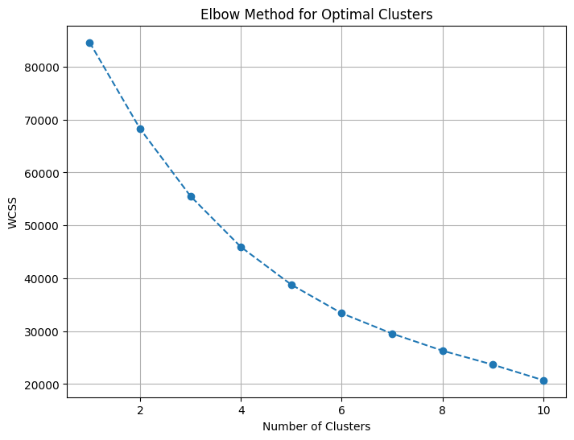**

1. **What is the count of different types of posts in the dataset?**

**Ans.**

***Code Snippet:***

**post_type_counts = fd['status_type'].value_counts()**

**print(post_type_counts)**

***Output:***

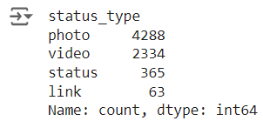

Most posts are photos while a very few are links.

1. **What is the average value of num_reaction, num_comments, num_shares for each post type?**

**Ans.**

***Code Snippet:***

**avg_values = fd.groupby('status_type')[['num_reactions', 'num_comments', 'num_shares']].mean().round()**

**print(avg_values)**

***Output:***

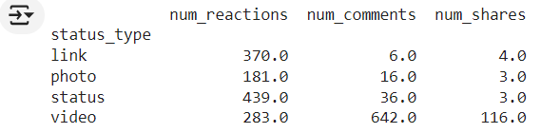

The above table shows the average no. of reactions, comments and shares for each post type.